**Dear DeJean Families,**

As the school year approaches its end, we are focused on maintaining a supportive and motivating environment to help students finish strong. Please encourage your child to set achievable goals for the remainder of the school year and provide guidance on prioritizing tasks needed to meet their goals. Our teachers are continuing bell-to-bell instruction and hope to keep students motivated and engaged by celebrating their achievements and providing positive feedback. We are also excited to invite our families to school-wide celebrations including the Black Excellence Awards, the DeJean Reclassification Ceremony, and our 8th Grade Promotion Ceremony.

**Academics:**

For the 8th graders to participate in the promotion ceremony, they may not have any Fs for their Q4 grades. We are posting lists weekly, so students can track their progress. We are also offering after-school tutoring for students in need of extra support. We hope that all 8th graders will have the opportunity to walk the stage at promotion! Please reach out to our academic counselor, Ms. Cruger-Hansen, for more information.

**Reminders:**

Although we are wrapping up this year, we are already beginning to plan for next school year. Our school site plan includes goals for parent engagement, school culture and climate, English Language Arts, Mathematics, Social Emotional Learning, and College and Career Readiness. Parent and guardian input is a crucial part of developing a plan that ensures the success of all students. We will review the 2024–2025 site plan and budget at the May 16 School Site Council Meeting. The meeting is on Zoom and all are welcome to join!

**Events and Family Engagement Opportunities**

**May 4 at 10 am: Cinco de May Parade**

* Join us in showing our DeJean Spirit and celebrating the various cultural traditions of our school community. All students and families are invited to walk in the parade.

**May 8, 10, 15, 17 at 9 am to 11 am: Parent Digital Literacy Classes**

* This will be our final cohort of digital literacy classes. The goal is for our parents to familiarize themselves with computer basics and receive a free laptop!

**May 9 at 6 pm: Black Excellence Awards/AAPAC meeting**

* We will be honoring our Black Scholars with awards and dinner. AAPAC will also meet to discuss the support of our African American students.

**March 16 at 6 pm: School Site Council Meeting**

* Join us to provide input on our plans for 2024 - 2025!

**May 24, May 27:** **No School**

* Reserved Day and Memorial Day

**May 30 at 6 pm: DeJean Reclassification Ceremony**

* We will be celebrating our students who have completed all requirements for reclassification from the ELD program.

**May 31 at 9 am: Final Coffee Chat with the Principal**

* Come have some pastries and coffee and chat with Principal Valdez!

**June 6 at 4 pm: 8th-grade Promotion Ceremony**

* Space is limited, so arrive early!

**June 7: Last day of school - noon dismissal**

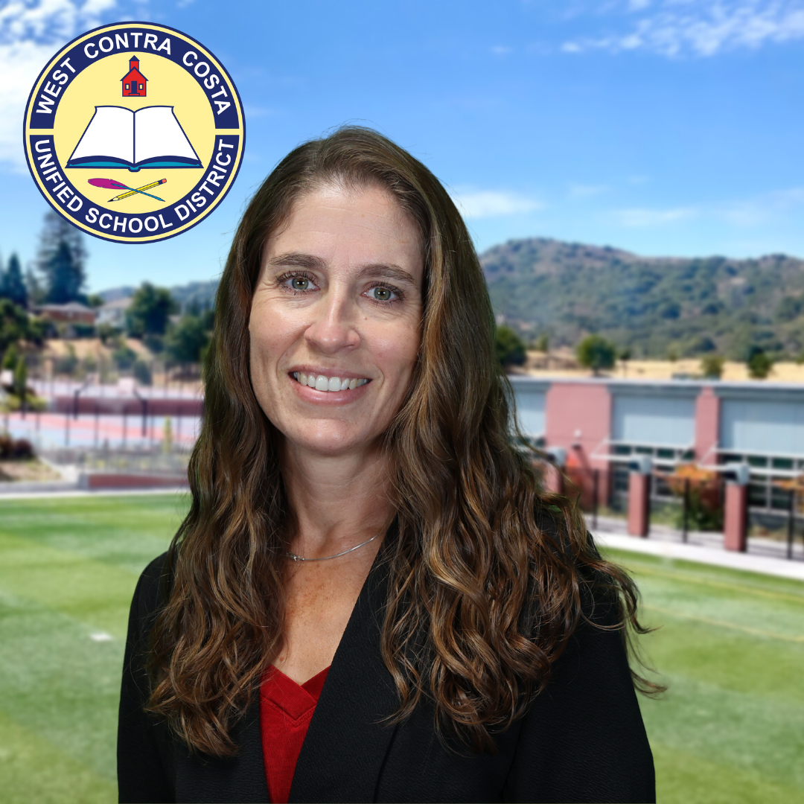

In Solidarity,

Athena Valdez

Principal